

Dynamics 365 – Inventory Management

Revision 1
Revision History

Date | Revision | Description | Signature / Date
13/10/2022 | 1 | Initial draft of user manual: Dynamics 365 – Inventory Management | Prepared | Waseem Abbas
 |  |  | Verified
 |  |  | Approved
 |  |  | Prepared
 |  |  | Verified
 |  |  | Approved
 |  |  | Prepared

Table of Contents
1 About User Manual 5
1.1 Dashboard Overview 5
2 On Hand 5
2.1 On Hand from Released Products 5
2.1.1 Released Product 5
2.1.2 Select and open on Hand Inventory 6
2.1.3 View on Hand Inventory 7
2.2 On hand from Inventory Management 7
2.2.1 Inventory Management 7
2.2.2 Select and open on Hand Inventory 7
2.2.3 View All on Hand Inventories 8
3 Counting Journal Creation 8
3.1 Counting 8
3.2 Create New Counting Journal 9
3.2.1 Add Line in the Journal 9
3.3 Fill the Fields in the Journal 10
4 Net Requirement 10
4.1 Select item and Open its Net Requirements 10
4.2 View Net Requirements of Item 11

List of Figures
Figure 1. Dashboard Overview 5
Figure 2 Released product 6
Figure 3 Select and open on Hand Inventory 6
Figure 4 View on Hand Inventory 7
Figure 5 Inventory Management 7
Figure 6 Select and open on Hand Inventory 8
Figure 7 View All on Hand Inventories 8
Figure 8 Counting 9
Figure 9 Create New Counting Journal 9
Figure 10 Add Line in the Journal 10
Figure 11 Fill the Fields in the Journal 10
Figure 12 Select item and Open its Net Requirements 11
Figure 13 View Net Requirements of Item 11

About User Manual
This document describes the step-by-step guide of on hand and net requirements of a product or a list of sub-products (items). These actions are typically performed by a purchase user (employee) in a legal entity (legal organization). The user can view the on hand and net requirements of the selected item.
The step-by-step guide for on hand items and net requirements will be explained.

Dashboard Overview
After logging in, you will see the main dashboard which includes the grid of individual workspaces (in the middle), which are represented in the Figure 1.
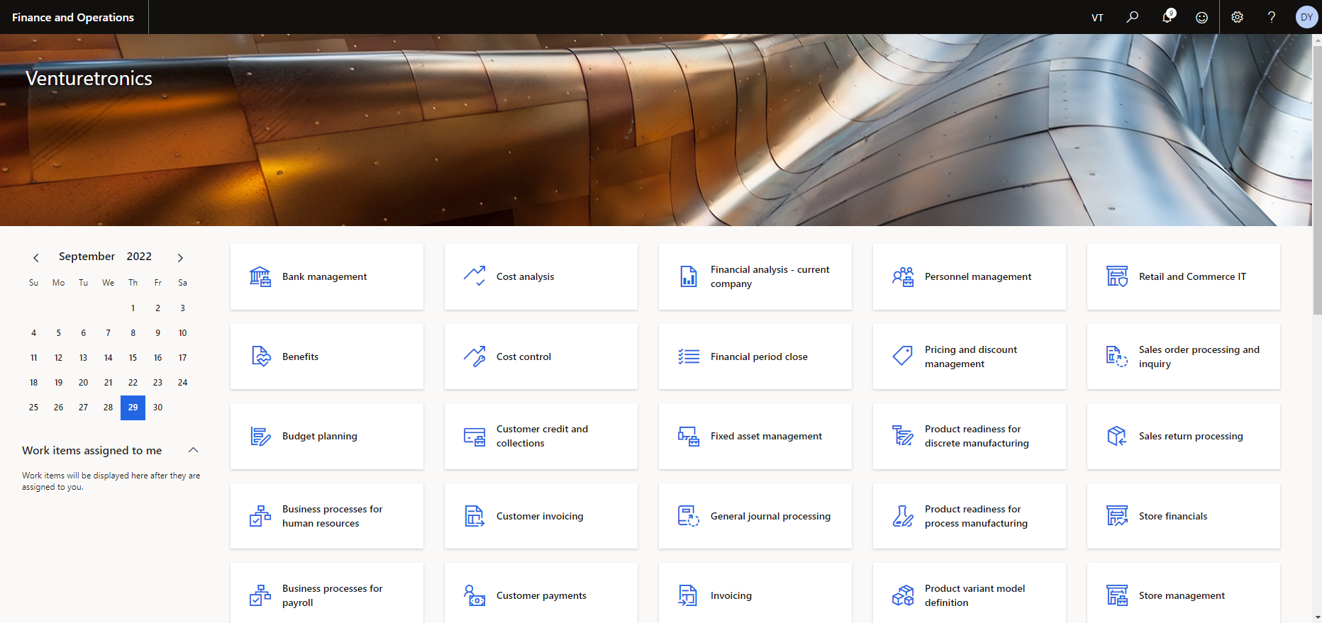
Figure 1. Dashboard Overview

On Hand
There are various ways to access the purchase order (PO) workspace.
Approach 1: From Released Products
If you want to view the one on hand item click on the Released Products from Product Information Management module, then click on the On-Hand Inventory from the manage inventory tab. These processes are already highlighted in the below Figures.
Approach 2: From Inventory Management
If you want to view the multiple on hand items click on the “On Hand Items” from Product Information Management module, then perform the action as per requirement to view the on-hand items. These processes are already highlighted in the below Figures.

On Hand from Released Products

Released Product
As a first step to open the released products by clicking on the module Product Information Management, which have been shown in Figure 2.
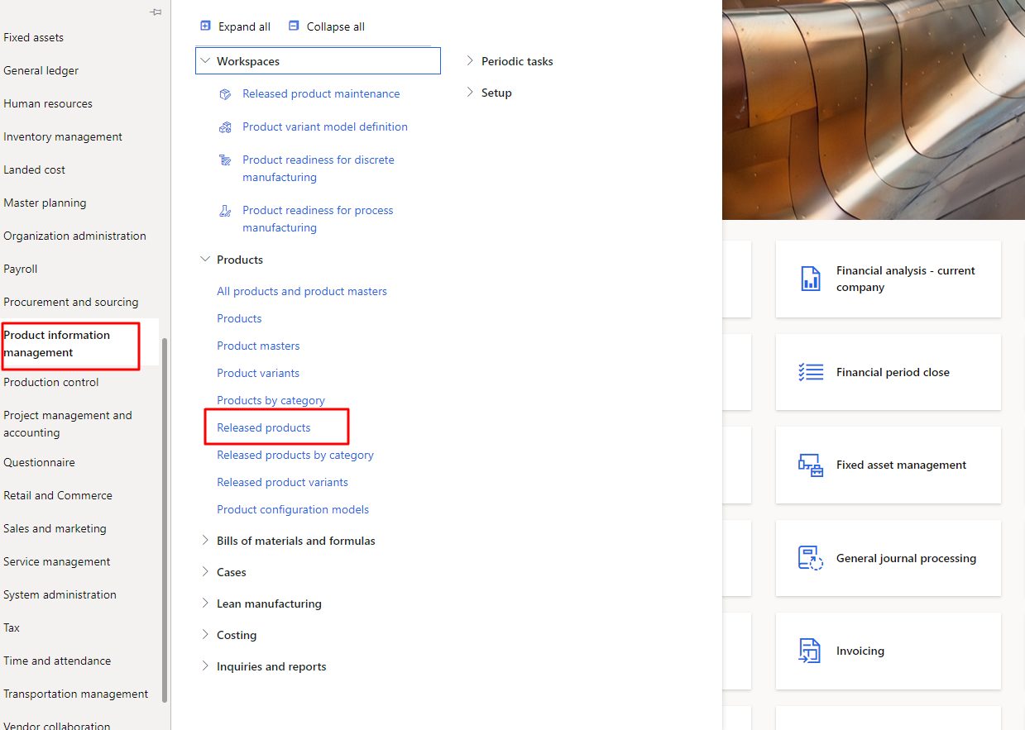
Figure 2 Released product

Select and open on Hand Inventory
As step 1, the purchase user can access the on-hand items by clicking on Manage Inventory button in tap bar. As the user click on Manage Inventory needs to perform the action on specific item to view it’s on hand inventory. The process is also shown in the Figure 3.
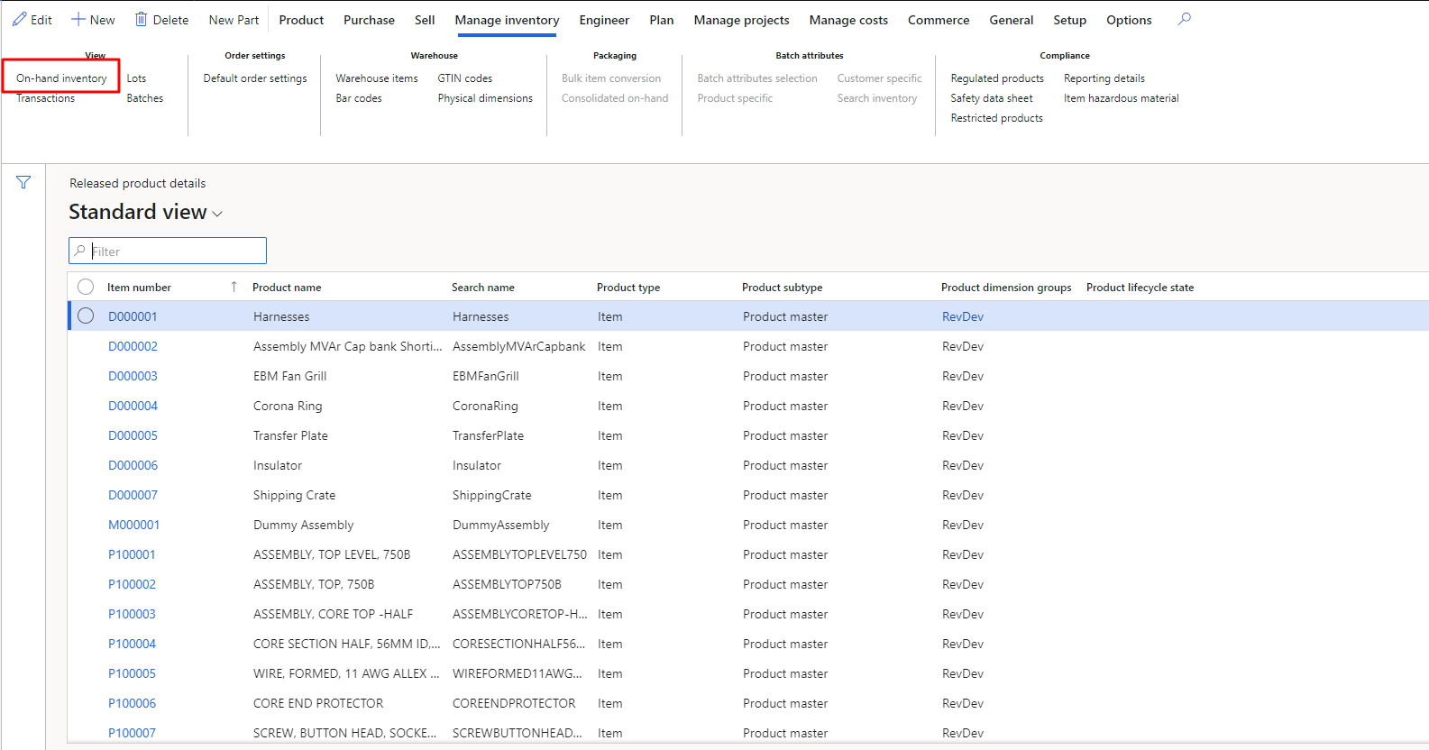
Figure 3 Select and open on Hand Inventory

View on Hand Inventory
In step 2, the purchase user can access this tab by opening the specific item to view it’s on hand inventory. As the user clicks on on-hand Inventory then this screen will show up. The user will be able to view the on-hand Inventory the selected item. The process is also shown in the Figure 4.
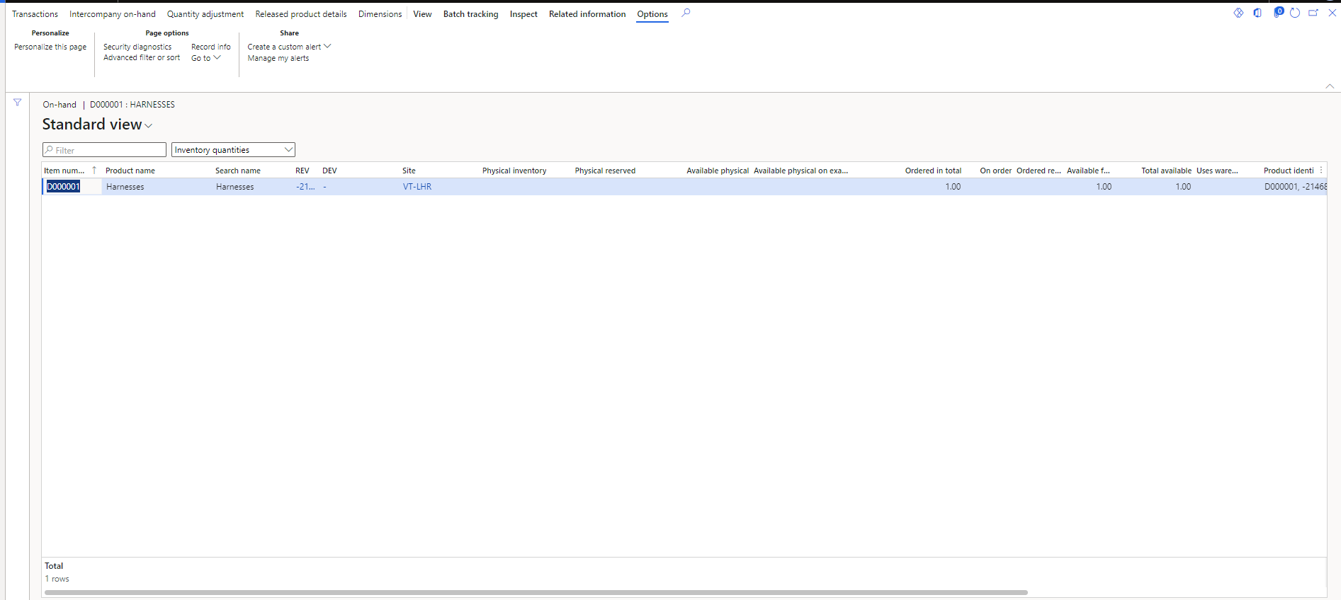
Figure 4 View on Hand Inventory

On hand from Inventory Management

Inventory Management
As a first step to open the on-hand item by clicking on the module Inventory Management, which have been shown in Figure 5.
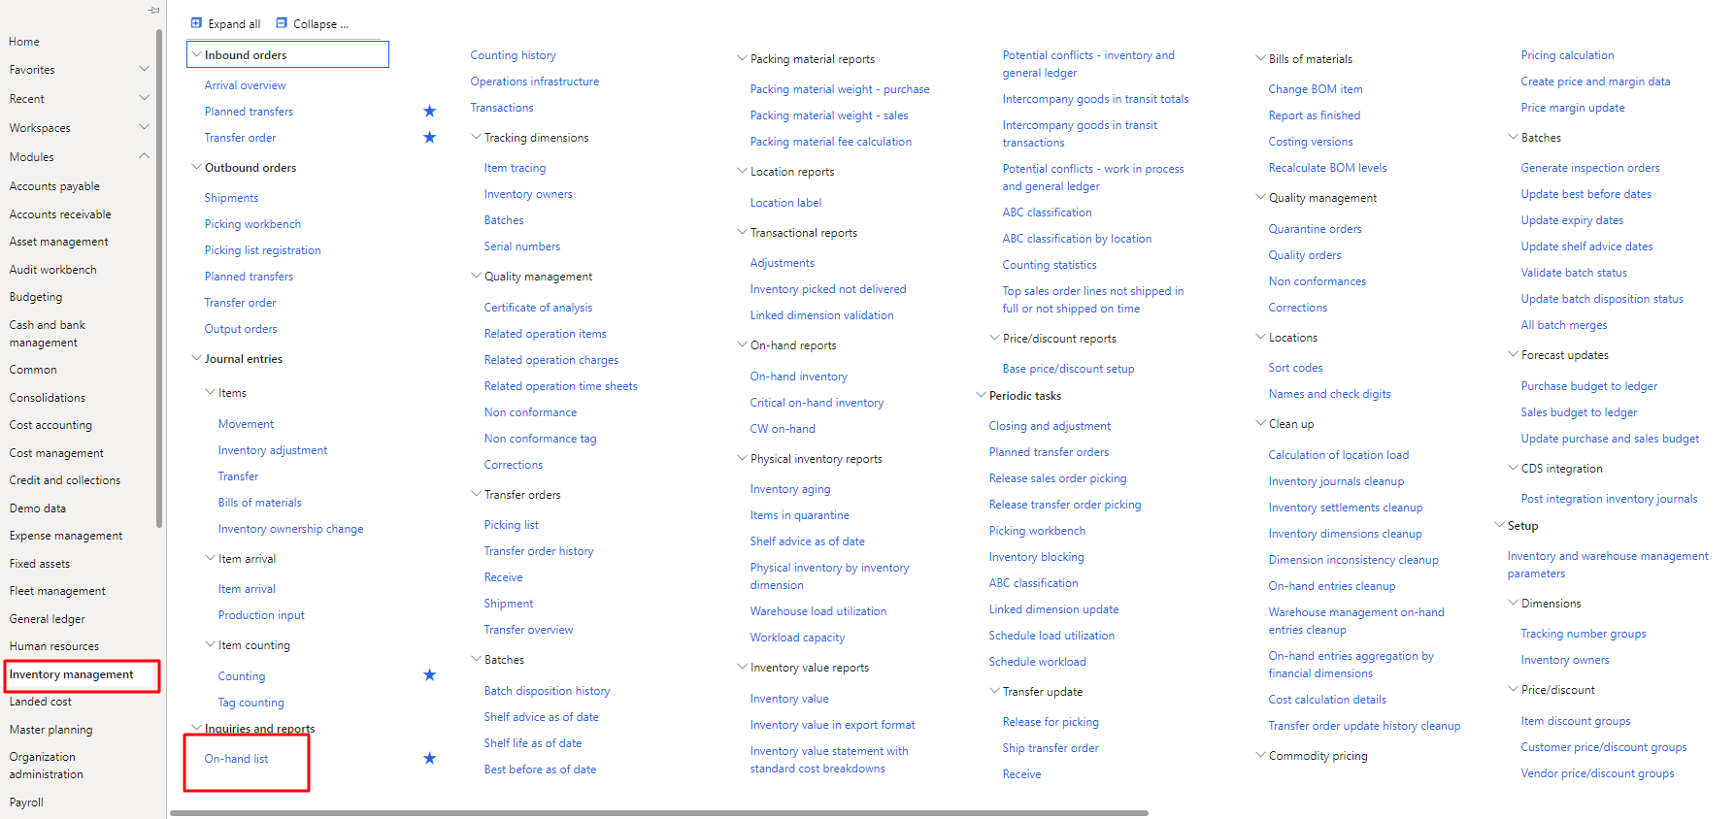
Figure 5 Inventory Management

Select and open on Hand Inventory
As step 1, the purchase user can access the on-hand items by clicking on on-hand items button. As the user click on on-hand items need to perform the action by clicking on apply button to view the on-hand items. The process is also shown in the Figure 6.
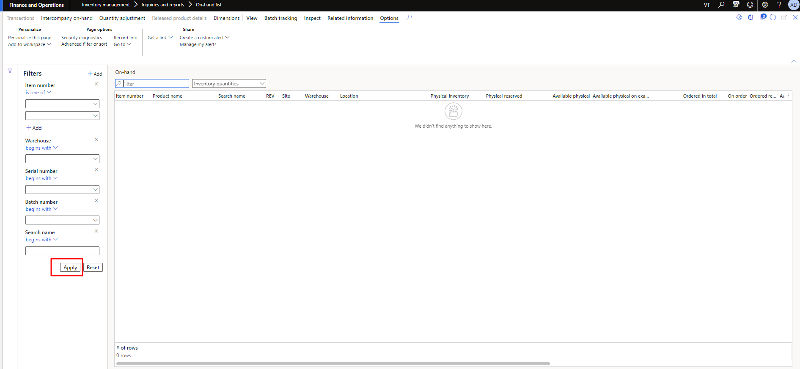
Figure 6 Select and open on Hand Inventory

View All on Hand Inventories
In step 2, the purchase user can access this tab by performing the action on apply button to view the on-hand items. As the user click on apply then this screen will show up, there user will be able to view the on-hand inventories. The process is also shown in the Figure 7.
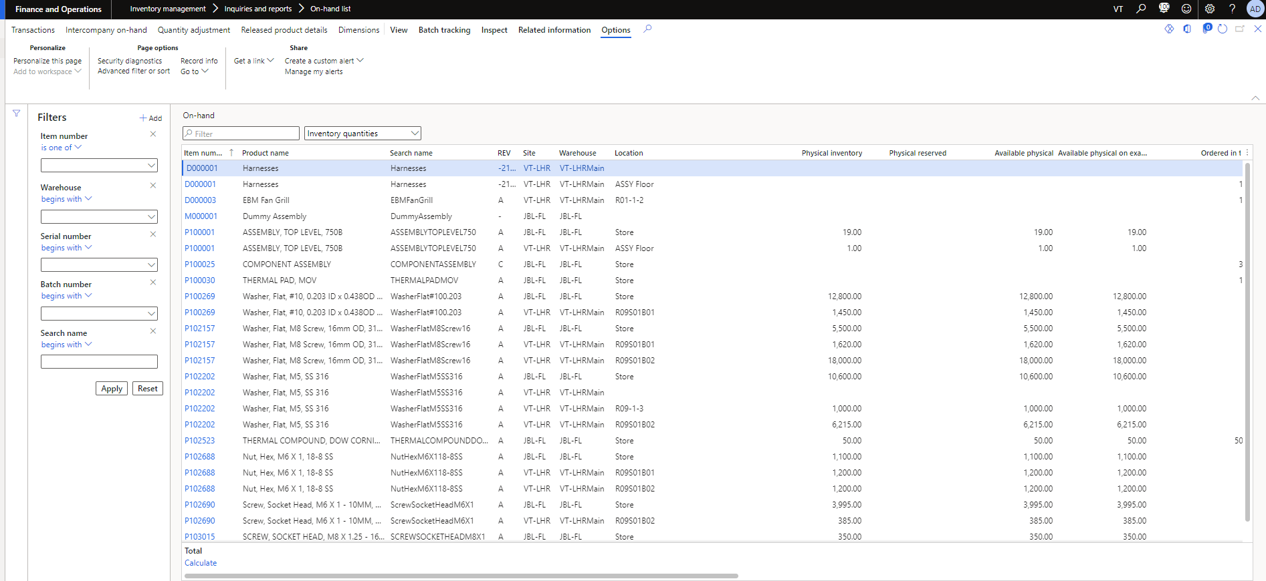
Figure 7 View All on Hand Inventories

Counting Journal Creation

Counting
As a first step to open the Counting Journal by clicking on the module Inventory Management then click on Counting, which have been shown in Figure 8.

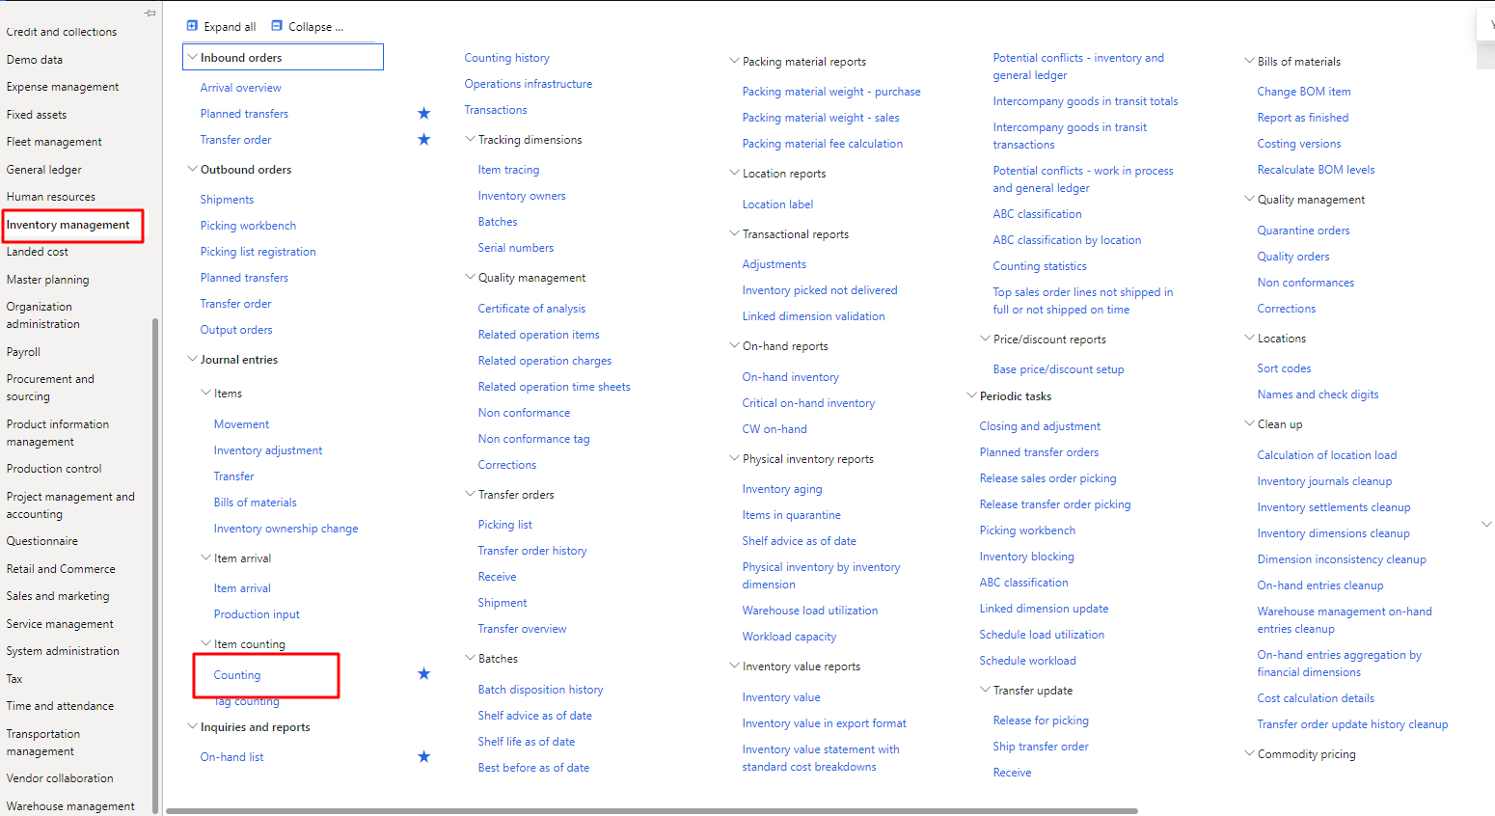
Figure 8 Counting

Create New Counting Journal
As step 1, the purchase user can access the counting journals by clicking on Counting button. User need to click on the New button from the tab to create the new one inventory journal. As the user click on New, this needs to fill the fields as per requirements and then press OK to create it. The process is also shown in the Figure 9.
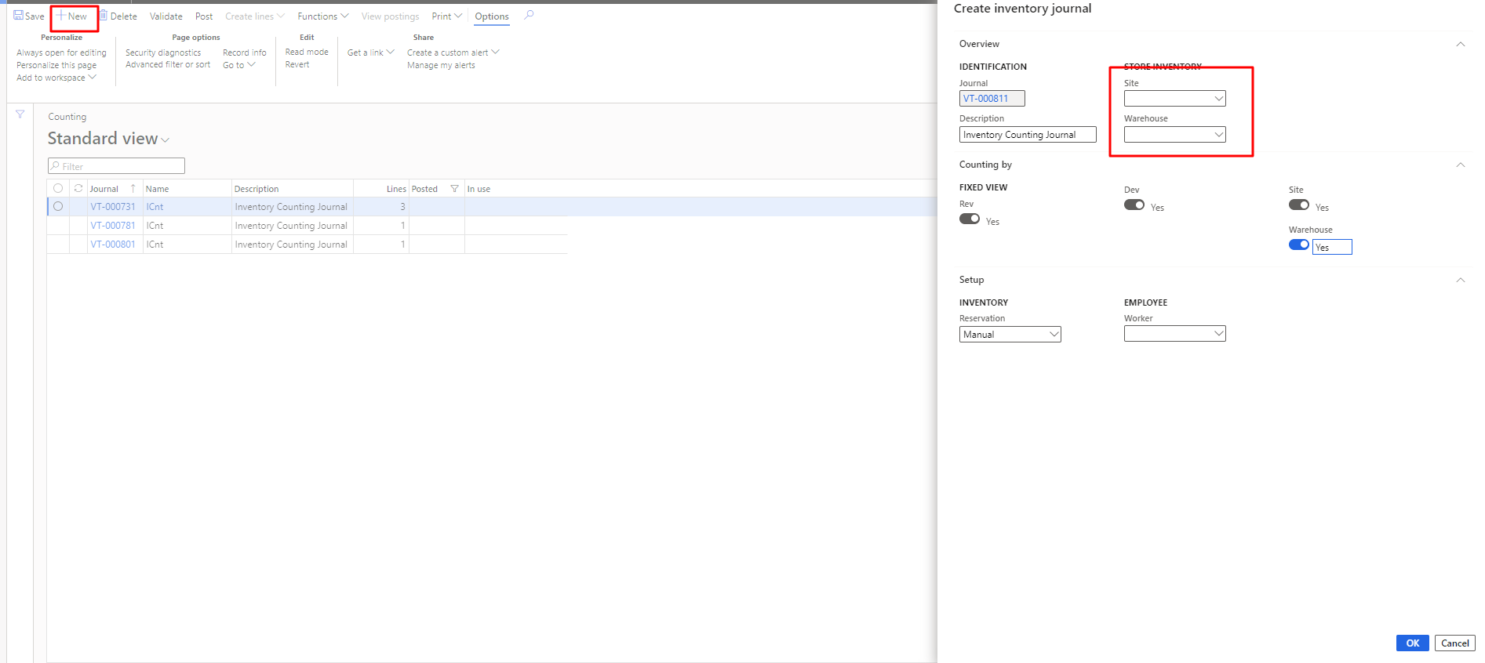
Figure 9 Create New Counting Journal

Add Line in the Journal
In step 2, the purchase user can access this tab after creating new Inventory Journal or opening the any available in the list. As the user open the any journal, there user need to add line and then fill the fields as per requirements. The process is also shown in the Figure 10.
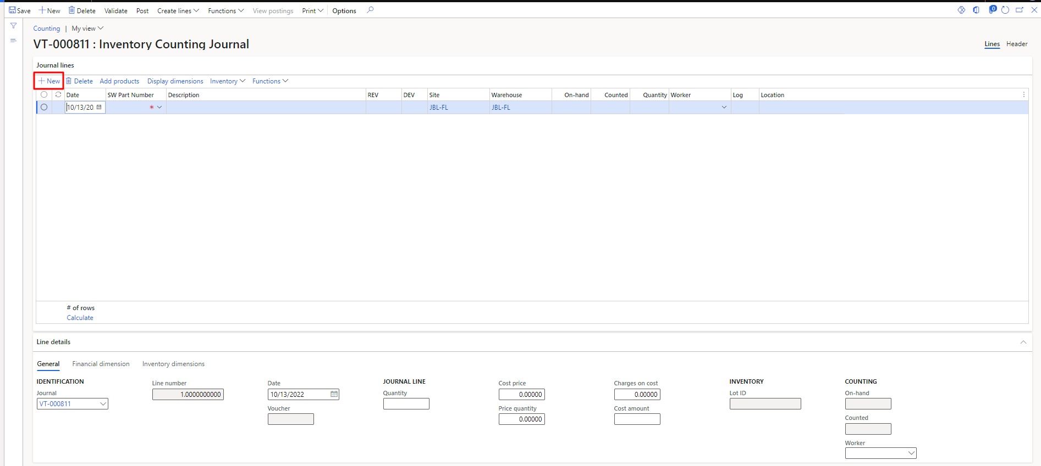
Figure 10 Add Line in the Journal

Fill the Fields in the Journal
In step 3, the purchase user can access this tab after creating new Inventory Journal or opening the any available in the list. As the user open the any journal, there user need to add Part Number, REV, DEV, Warehouse, Counted, Location, Cost Price and Price Quantity. The process is also shown in the Figure 11.
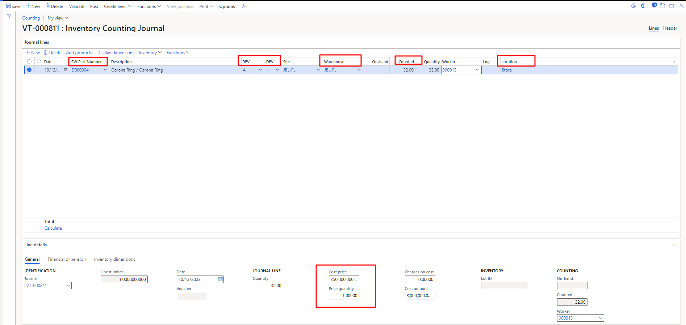
Figure 11 Fill the Fields in the Journal

Net Requirement

Select item and Open its Net Requirements
As step 1, the purchase user can access the Net Requirements by clicking on Plan button in tap bar. As the user click on Plan need to perform the action on specific item to view its Net Requirements. The process is also shown in the Figure 12.
.
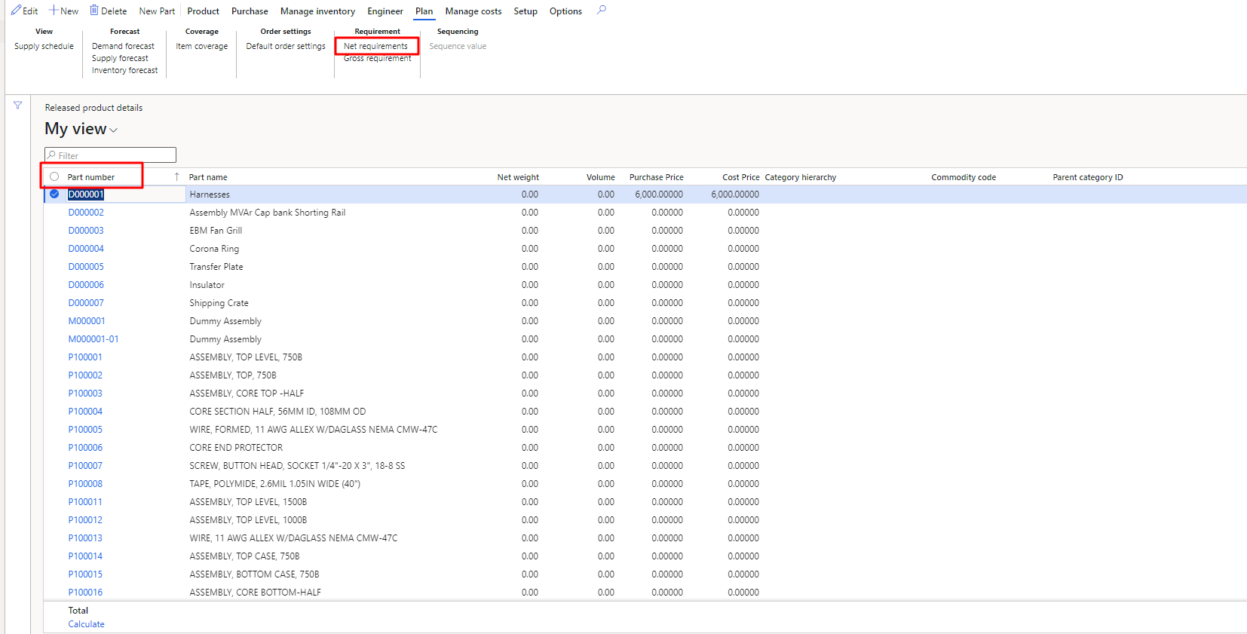
Figure 12 Select item and Open its Net Requirements

View Net Requirements of Item
In step the purchase user can access this tab by opening the specific item to view its Net Requirements. As the user click on Net Requirement then this screen will show up. The user will be able to view the Net Requirements of the selected item. The process is also shown in the Figure 13.
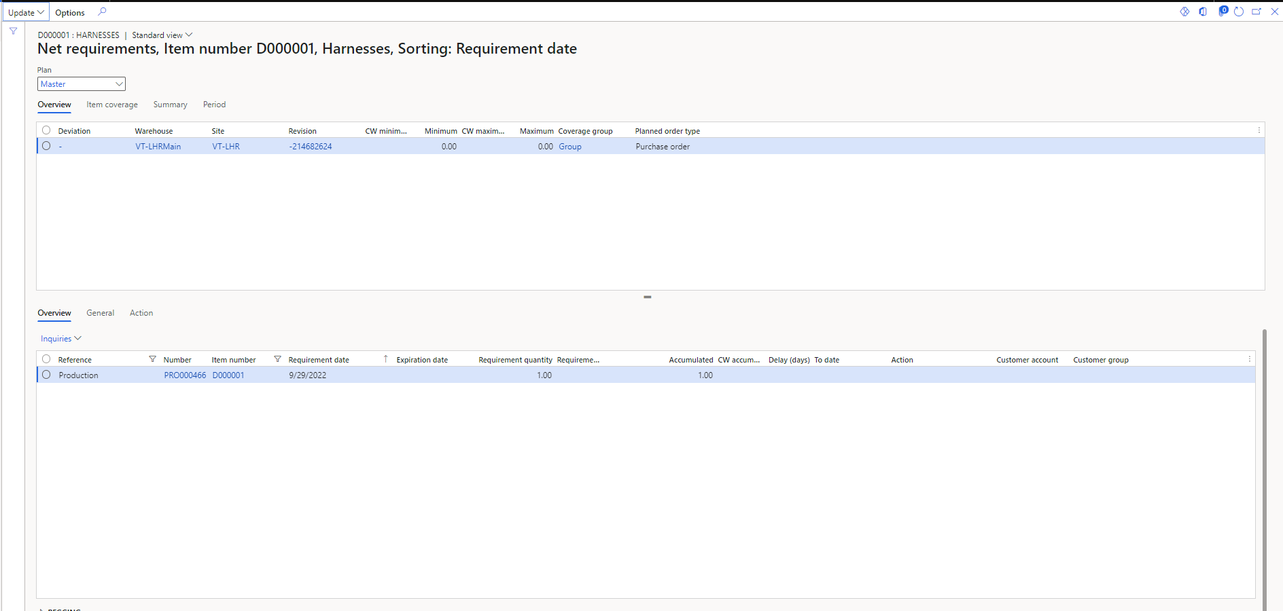
Figure 13 View Net Requirements of Item

